EXPERIMENT 02
PERFORM WEBSITE, EMAIL, WHOIS, DNS, AND NETWORK FOOTPRINTING ON TARGET NETWORK

1. AIM
To gather detailed technical infrastructure information—including domain registration details, DNS zone records, email routing servers, web tech stacks, and network topology—using standard CLI tools and web utilities.

2. THEORY
Technical footprinting analyzes the target's core internet infrastructure without initiating invasive attacks.
• Whois Footprinting: Queries regional internet registries (ARIN, RIPE) for domain ownership, administrative contacts, creation/expiration dates, and authoritative name servers.
• DNS Footprinting: Queries DNS server records (A, MX, NS, TXT, CNAME) to map internal infrastructure and check for misconfigured zone transfers (AXFR).
• Network Footprinting: Uses ICMP/UDP packet routing to trace path topology, intermediate router hops, and boundary firewalls.

3. TOOLS REQUIRED
- whois CLI
- nslookup & dig utilities
- traceroute utility
- WhatWeb & Netcraft
- Browser Web Developer Tools

4. PROCEDURE & COMMANDS
Step 1: Perform Domain Whois Lookup
Query domain registration records from the terminal:
whois targetcompany.com

Step 2: Execute DNS Infrastructure Footprinting
Query host IP addresses (A records), mail exchange servers (MX records), name servers (NS records), and attempt a zone transfer (AXFR):
nslookup targetcompany.com
nslookup -type=mx targetcompany.com
dig targetcompany.com ANY
dig targetcompany.com NS
dig targetcompany.com TXT
dig axfr @nameserver targetcompany.com

Step 3: Fingerprint Web Technology Stack
Inspect HTTP response headers, developer comments, and technology stacks using WhatWeb:
whatweb targetcompany.com

Step 4: Trace Network Route Topology
Determine the network hops and boundary routing devices leading to the target server:
traceroute targetcompany.com

5. LAB OBSERVATIONS & OUTPUT SCREENSHOTS
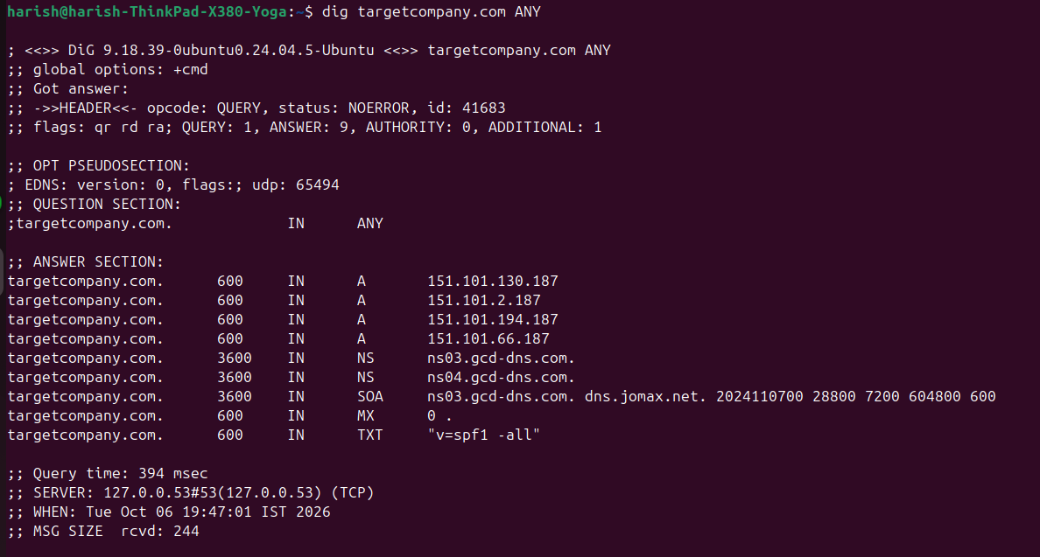

6. EXPECTED OUTPUT RESULT
A technical infrastructure profile documenting Whois registration data, DNS records (A, MX, NS, TXT), identified web server versions, programming languages, and the network path routing trace.

7. VIVA VOCE QUESTIONS & ANSWERS
S.NO & VIVA QUESTION | TECHNICAL ANSWER
Q1. What information does a Whois lookup provide? | Whois provides domain registration details, registrant organization, administrative/technical contacts, domain creation and expiration dates, and primary/secondary name servers.
Q2. What is the difference between an A record and an MX record in DNS? | An 'A' record maps a domain name directly to an IPv4 address. An 'MX' record designates the mail server responsible for receiving email for that domain.
Q3. What is a DNS zone transfer, and why is it a security risk if misconfigured? | A DNS zone transfer (AXFR) replicates the entire DNS database between servers. If publicly accessible, an attacker can download all internal subdomains, hostnames, and IP mappings.
Q4. How can viewing a website's page source help in footprinting? | Page source code reveals hidden developer comments, unlinked internal links, front-end JS library versions, inline API endpoints, and form input names.
Q5. What does traceroute show, and how is it useful to an attacker? | Traceroute displays all intermediate router hops and packet delay times to a target. It helps attackers map network topology and identify firewalls/gateways.

